Contents

Framework Description 2

Separate Page and Test Classes: 2

Commonly used Features in Core package 3

Screenshots 3

Properties file for test data 4

Extent Report 4

Hardware and Software Description 5

Screenshots from Appium Desktop Inspector 6

**Automation Framework Details**

# Framework Description

I have used Page Object Model pattern for this assessment. Scripting language is used as Java and TestNG as framework.

This is a maven project and pom.xml contains all the required dependencies.

## Separate Page and Test Classes:

There are separate page and test classes in the framework. Page classes are having only locators and modular actions on those locators while test classes are the actual test cases which are in flow by using modular action methods of page classes.

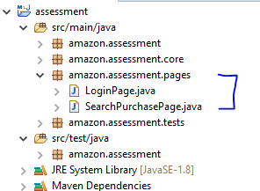

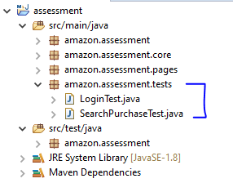

## Commonly used Features in Core package

All the commonly used features are put in a separate package name Core. Which is having Base, CommonHelper and ExtentReporterNG class (to generate Extent Report).

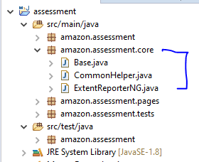

## Screenshots

Screenshot method is written in CommonHelper class within Core package and it called throughout the code wherever required. The captured screenshots are placed with ‘ScreenShots’ folder.

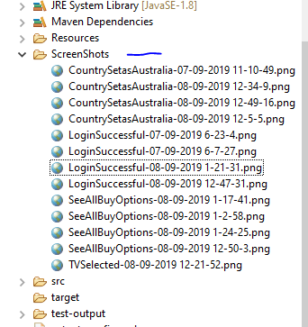

## Properties file for test data

A separate properties file is used to keep our test data which is calling to load test data in required test method. This properties file is located under ‘Resources’ folder.

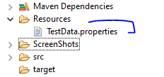

## Extent Report

After end of the test execution, TestNG will be created it default Emailable Report and Index report. Apart from these two reports we will get one more Extent Report which is very useful and rich GUI based. This can be found at ‘test-output -> ExtentReportSTestNG.httml’

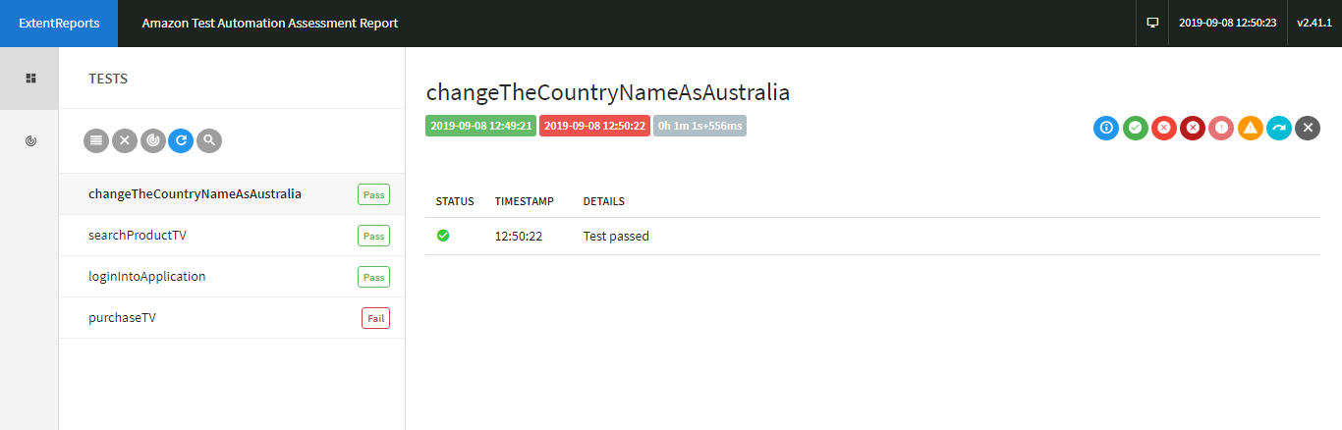

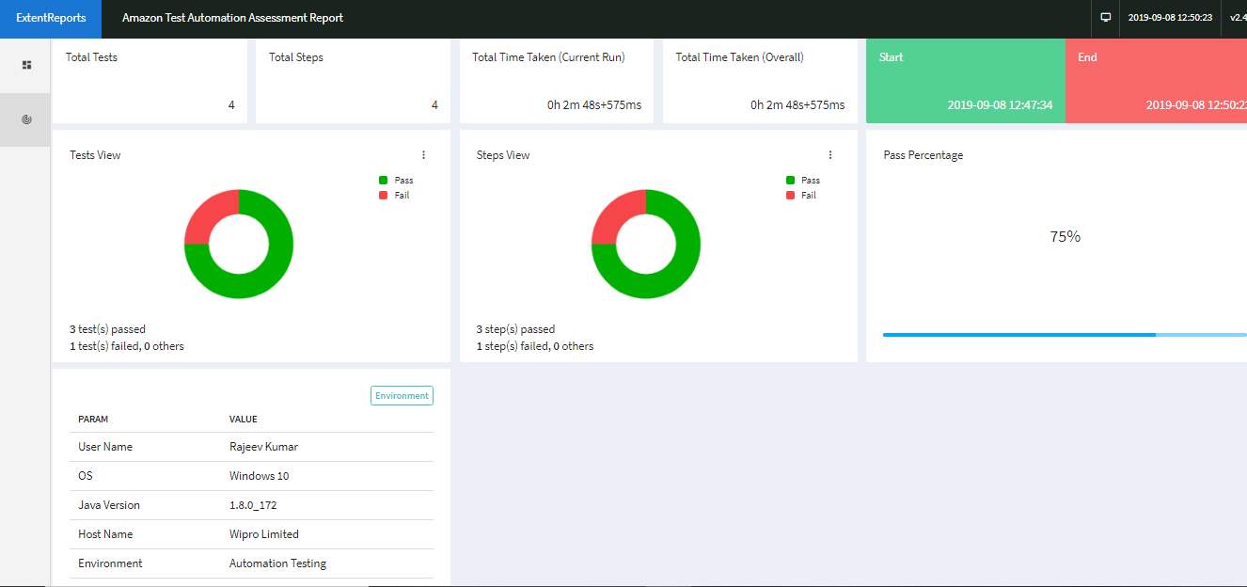

# Hardware and Software Description

Mobile: Moto G4 Plus

Mobile OS: Android 7.0

Appium Desktop: 1.13.0

Appium Server: 1.13.0

# Screenshots from Appium Desktop Inspector

1. Launching the app in Appium Desktop:

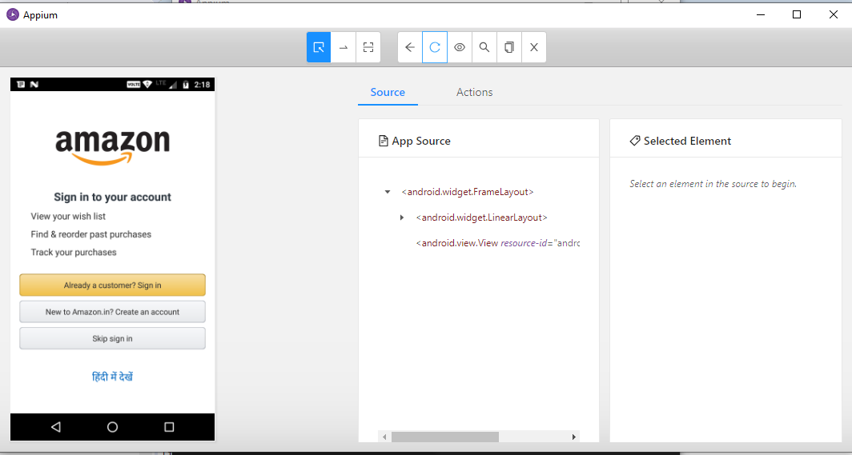

1. Id of sign in button

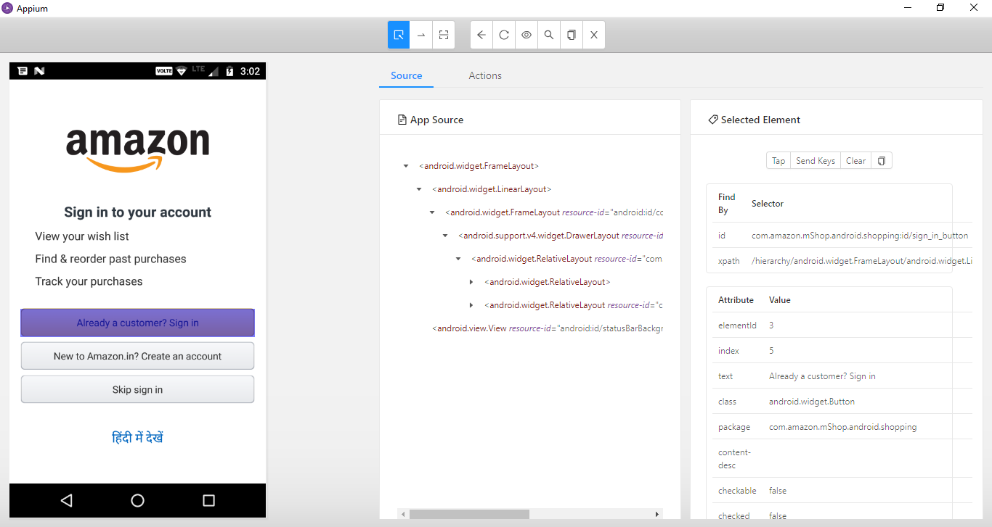

1. Password screen

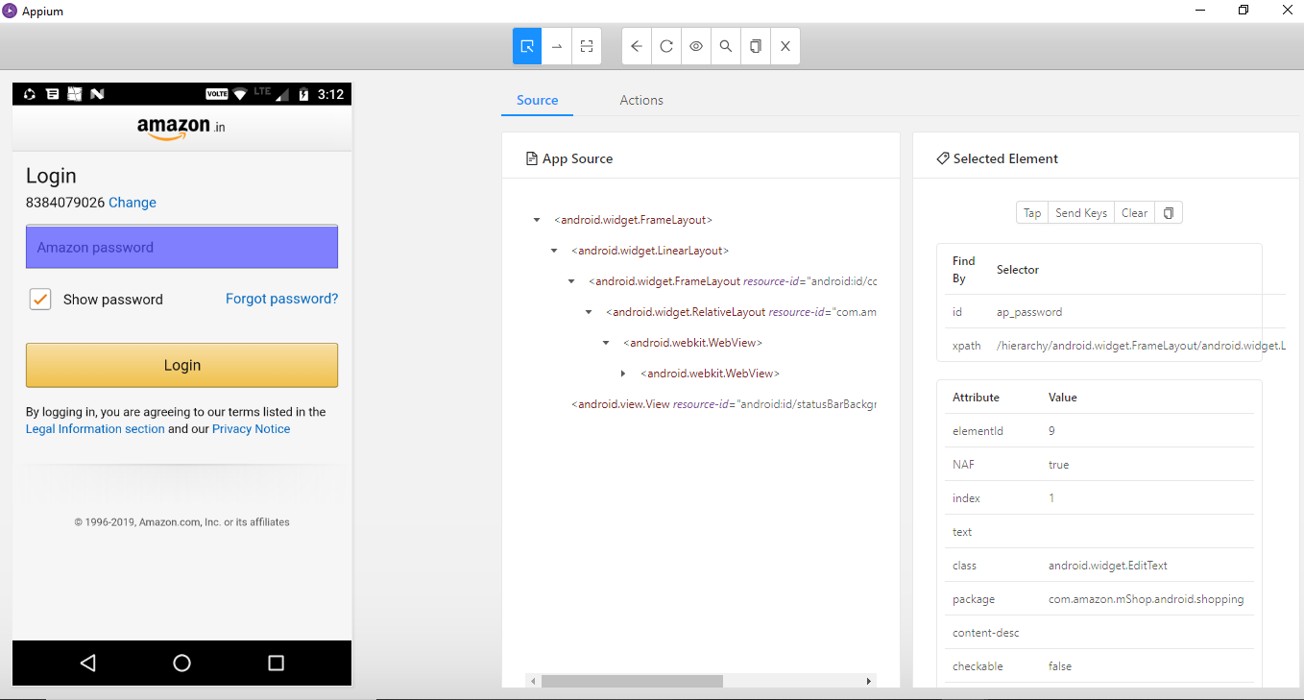

1. Searched TV description

